Java Programming(314317) MSBTE PRACTICAL QUESTION

- Write a program to accept age from user and throw an exception if age is less than 18.
- // Write a program to accept age from user and throw an exception if age is less than 18.
- import java.util.Scanner;
- class AgeException extends Exception {
- AgeException(String message) {
- super(message);
- }
- }
- public class Q_1 {
- public static void main(String[] args) {
- try {
- Scanner sc = new Scanner(System.in);
- System.out.print("Enter your age:");
- int age = sc.nextInt();
- sc.close();
- if (age < 18) {
- throw new AgeException("You're less than 18.");
- } else {
- System.out.println("No problem.");
- }
- } catch (AgeException e) {
- System.out.println("Exception caught: " + e.getMessage());
- }
- }
- }

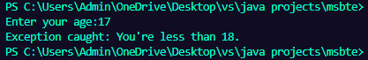

2. Write a program to use Label, TextField and Button to create login form. When user clicks the button, login successful/ unsuccessful message should be displayed.
// Write a program to use Label, TextField and Button to create login form. When user clicks the button, login successful/ unsuccessful message should be displayed.
import javax.swing.*;
import java.awt.event.*;
import java.awt.*;
public class Q_2 extends JFrame implements ActionListener {
JLabel l1, l2, l3;
JTextField t1, t2;
JButton b1;
Q_2() {
setLayout(new FlowLayout());
setVisible(true);
setSize(300, 150);
setDefaultCloseOperation(JFrame.EXIT_ON_CLOSE);
l1 = new JLabel("Username:");
t1 = new JTextField(20);
l2 = new JLabel("Password:");
t2 = new JTextField(20);
b1 = new JButton("Login");
b1.addActionListener(this);
l3 = new JLabel("");
add(l1);
add(t1);
add(l2);
add(t2);
add(b1);
add(l3);
}
public void actionPerformed(ActionEvent e) {
String username = (String)t1.getText();
String password = (String)t2.getText();
if (username.equals("admin") && password.equals("1234")) {
l3.setText("Login successful");
} else {
l3.setText("Login unsuccessful");

}
}
public static void main(String[] args) {
new Q_2();
}
}
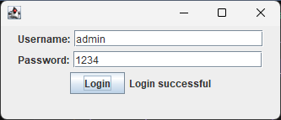

3. Write a program to create two threads. Thread A should print even numbers from 1 to 50 and thread B should print odd numbers from 1 to 50.
// Write a program to create two threads. Thread A should print even numbers from 1 to 50 and thread B should print odd numbers from 1 to 50.
class A extends Thread {
public void run() {
for (int i = 1; i <= 50; i++) {
if (i % 2 == 0) {
System.out.println("Thread A: " + i);
}
}
}
}
class B extends Thread {

public void run() {
for (int i = 1; i <= 50; i++) {
if (i % 2 != 0) {
System.out.println("Thread B: " + i);
}
}
}
}
public class Q_3 {
public static void main(String[] args) {
A a = new A();
B b = new B();
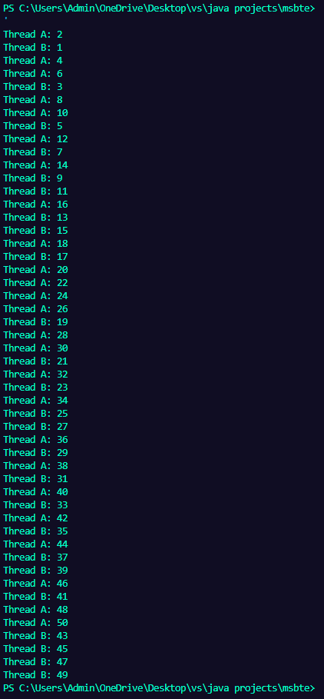
a.start();
b.start();
}
}

4. Write a program to list five states using JcomboBox. Display selected item in JTextfield.
// Write a program to list five states using JcomboBox. Display selected item in JTextfield.
import javax.swing.*;
import java.awt.*;
import java.awt.event.*;
public class Q_4 extends JFrame implements ActionListener {
JComboBox<String> comboBox;
JTextField textField;
Q_4() {
setLayout(new FlowLayout());
setVisible(true);
setSize(300, 150);
setDefaultCloseOperation(JFrame.EXIT_ON_CLOSE);
String[] states = {"Maharashtra", "Gujarat", "Rajasthan", "Punjab", "Haryana"};
comboBox = new JComboBox<>(states);
comboBox.addActionListener(this);
textField = new JTextField(20);
add(comboBox);
add(textField);
}
public void actionPerformed(ActionEvent e) {
String selectedState = (String) comboBox.getSelectedItem();
textField.setText(selectedState);
}
public static void main(String[] args) {
new Q_4();
}
}

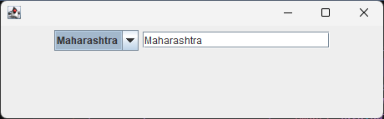
5. Write a program to use JTextField, JLabel and JButton to add two numbers and display the output. Use Gridlayout.
//Write a program to use JTextField, JLabel and JButton to add two numbers and display the output. Use Gridlayout.
import javax.swing.*;
import java.awt.*;
import java.awt.event.*;
public class Q_5 extends JFrame implements ActionListener {
JLabel l1, l2, l3;
JTextField t1, t2, t3;
JButton b1;
Q_5() {
setLayout(new GridLayout(4,2,10,10));
setVisible(true);
setSize(300, 200);
setDefaultCloseOperation(JFrame.EXIT_ON_CLOSE);
l1 = new JLabel("Number 1:");
t1 = new JTextField(20);
l2 = new JLabel("Number 2:");
t2 = new JTextField(20);
b1 = new JButton("Add");
b1.addActionListener(this);
l3 = new JLabel("Result:");
t3 = new JTextField(20);
add(l1);
add(t1);
add(l2);
add(t2);
add(new JLabel());
add(b1);
add(l3);
add(t3);
}
public void actionPerformed(ActionEvent e) {
int num1 = Integer.parseInt(t1.getText());
int num2 = Integer.parseInt(t2.getText());
int sum = num1 + num2;
t3.setText(Integer.toString(sum));
}
public static void main(String[] args) {
new Q_5();
}
}
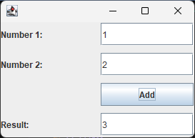

6. Write a program to read and display content from the url “http://www.google.com”
// Write a program to read and display content from the url “http://www.google.com”
import java.net.*;
import java.io.*;
public class Q_6 {
public static void main(String[] args) throws Exception {
URL url = new URL("http://www.google.com");
URLConnection urlConnection = url.openConnection();
BufferedReader in = new BufferedReader(new InputStreamReader(urlConnection.getInputStream()));
String inputLine;
while ((inputLine = in.readLine()) != null) {
System.out.println(inputLine);
}
in.close();
}
}

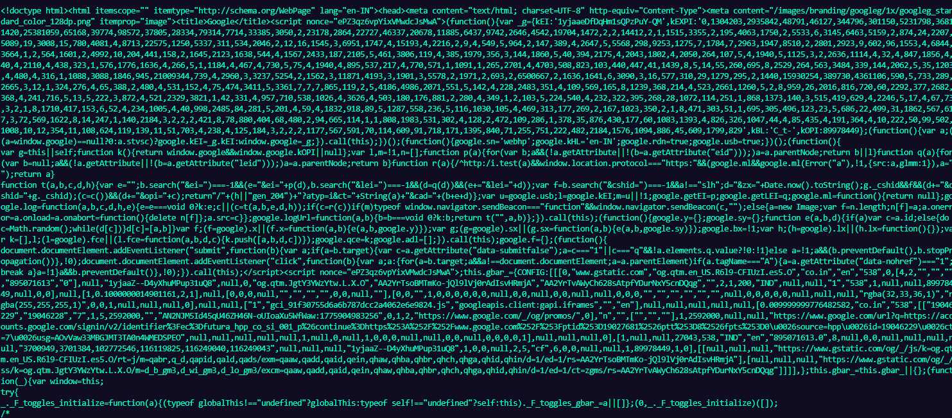
7. Write a program to use keylistener to display characters entered by user.
// Write a program to use keylistener to display characters entered by user.
import javax.swing.*;
import java.awt.event.*;
import java.awt.*;
public class Q_7 extends JFrame implements KeyListener {
JTextField textField;
JLabel label;
Q_7() {
setLayout(new FlowLayout());
setVisible(true);
setSize(300, 150);
setDefaultCloseOperation(JFrame.EXIT_ON_CLOSE);
textField = new JTextField(20);
textField.addKeyListener(this);
label = new JLabel("");
add(textField);
add(label);
}
public void keyTyped(KeyEvent e) {
char ch = e.getKeyChar();
label.setText("You entered: " + ch);
}
public void keyPressed(KeyEvent e) {
char ch = e.getKeyChar();
label.setText("You entered: " + ch);
}
public void keyReleased(KeyEvent e) {
char ch = e.getKeyChar();
label.setText("You entered: " + ch);
}
public static void main(String[] args) {
new Q_7();
}
}

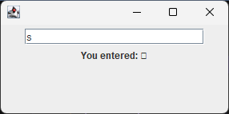
8. Write a program to display the list of employees of deptno 10 from the table employee (eno, ename, salary, deptno). Use prepared statement.
// Write a program to display the list of employees of deptno 10 from the table employee (eno, ename, salary, deptno). Use prepared statement.
import java.sql.*;
public class Q_8 {
public static void main(String[] args) {
try {
Class.forName("com.mysql.cj.jdbc.Driver");
Connection connection = DriverManager.getConnection("jdbc:mysql://localhost:3306/my_db","root","1234");
PreparedStatement ps = connection.prepareStatement("SELECT eno, ename, salary FROM employee WHERE deptno = ?");
ps.setInt(1, 10);
ResultSet rs = ps.executeQuery();
while (rs.next()) {
System.out.println("ENO: " + rs.getInt("eno") + ", ENAME: " + rs.getString("ename") + ", SALARY: " + rs.getInt("salary"));
}
} catch (Exception e) {
e.printStackTrace();
}
}
}

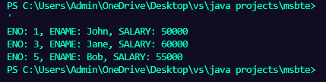
9. Write a program to implement the following :
i) Create vector and add 2 Integer, 2 Double and 1 Float objects. ii)Add string object to 3rd position.
iii) Remove element specified by user. iv) Display all elements in vector.
v) Remove all elements from vector. vi) Display capacity of vector.
/*Write a program to implement the following :
i) Create vector and add 2 Integer, 2 Double and 1 Float objects. ii)Add string object to 3rd position.
iii) Remove element specified by user. iv) Display all elements in vector.
v) Remove all elements from vector. vi) Display capacity of vector. */
import java.util.Vector;
import java.util.Scanner;
public class Q_9 {
public static void main(String[] args) {
Vector<Object> v = new Vector<>();
v.add(10);
v.add(20);
v.add(3.14);
v.add(2.718);
v.add(1.5f);
v.add(3, "Hello");
Scanner sc = new Scanner(System.in);
System.out.print("Enter index of element to remove:");
int index = sc.nextInt();
v.removeElementAt(index);
System.out.println("Element removed.");
sc.close();
System.out.println("Elements in vector:");
for (Object obj : v) {
System.out.println(obj);
}
v.clear();
System.out.println("All elements removed.");
System.out.println("Capacity of vector: " + v.capacity());
}
}

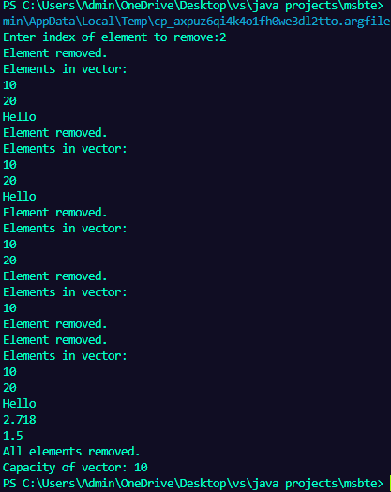
10. Write a program to display folder structure of computer using JTree.
// Write a program to display folder structure of computer using JTree.
import javax.swing.*;
import java.awt.*;
import javax.swing.tree.*;
public class Q_10 extends JFrame {
Q_10() {
setLayout(new FlowLayout());
setVisible(true);
setSize(400,150);
setDefaultCloseOperation(JFrame.EXIT_ON_CLOSE);
DefaultMutableTreeNode root = new DefaultMutableTreeNode("This PC");
DefaultMutableTreeNode driveC = new DefaultMutableTreeNode("C:");
DefaultMutableTreeNode driveD = new DefaultMutableTreeNode("D:");
DefaultMutableTreeNode folder1 = new DefaultMutableTreeNode("Program Files");
DefaultMutableTreeNode folder2 = new DefaultMutableTreeNode("Documents");
DefaultMutableTreeNode games = new DefaultMutableTreeNode("Games");
root.add(driveC);
root.add(driveD);
driveC.add(folder1);
driveC.add(folder2);
driveD.add(games);
JTree tree = new JTree(root);
add(new JScrollPane(tree));
}
public static void main(String[] args) {
new Q_10();
}
}

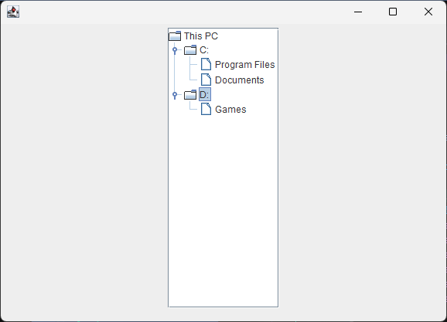
11.
interface Exam {
double Sports_wt = 20;
}
class student {
int rollno;
String name;
double marks1, marks2, marks3;
student() {
rollno = 1;
name = "AA";
marks1 = 70;
marks2 = 80;
marks3 = 90;
}
}
class Result extends student implements Exam {
double total_marks;
double percentage;
void calculate() {
total_marks = marks1 + marks2 + marks3 + Sports_wt;
percentage = (total_marks / 400) * 100;
}
void display() {
System.out.println("Roll No: " + rollno);
System.out.println("Name: " + name);
System.out.println("Total Marks: " + total_marks);
System.out.println("Percentage: " + percentage);
}
}
public class Q_11 {
public static void main(String[] args) {
Result r = new Result();
r.calculate();
r.display();
}
}

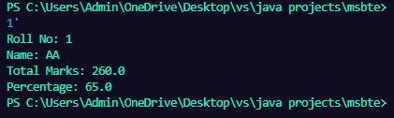

12. Write a program to display the protocol, host, port and file of URL (Accept URL from user).
// Write a program to display the protocol, host, port and file of URL (Accept URL from user).
import java.net.*;
public class Q_12 {
public static void main(String[] args) {
try {
URL url = new URL("https://mmpolytechnic.edu.in");
System.out.println("Protocol: " + url.getProtocol());
System.out.println("Host: " + url.getHost());
System.out.println("Port: " + url.getPort());
System.out.println("File: " + url.getFile());
} catch (MalformedURLException e) {
System.out.println(e);
}
}
}

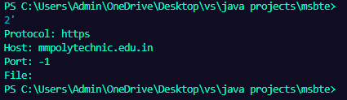
13. Write a program to list the empno, ename and salary of five employees using JTable.
import java.awt.*;
import javax.swing.*;
// Write a program to list the empno, ename and salary of five employees using JTable.
public class Q_13 extends JFrame {
Q_13() {
setLayout(new FlowLayout());
setVisible(true);
setSize(400, 200);
setDefaultCloseOperation(JFrame.EXIT_ON_CLOSE);
String[] columnNames = {"Emp No", "Emp Name", "Salary"};
Object[][] data = {
{1, "AA", 50000},
{2, "BB", 60000},
{3, "CC", 55000},
{4, "DD", 70000},
{5, "EE", 45000}
};
JTable table = new JTable(data, columnNames);
add(new JScrollPane(table));
}
public static void main(String[] args) {
new Q_13();
}
}

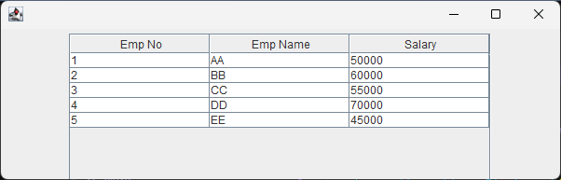
14. Write a program using URL and URLConnection class to retrieve the date, content type, content of any entered URL.
// Write a program using URL and URLConnection class to retrieve the date, content type, content of any entered URL.
import java.net.*;
import java.io.*;
public class Q_14 {
public static void main(String[] args) {
try {
URL url = new URL("https://mmpolytechnic.edu.in");
URLConnection urlConnection = url.openConnection();
BufferedReader in = new BufferedReader(new InputStreamReader(urlConnection.getInputStream()));
String inputLine;
while ((inputLine = in.readLine()) != null) {
System.out.println(inputLine);
}
in.close();
System.out.println("Date: " + urlConnection.getDate());
System.out.println("Content Type: " + urlConnection.getContentType());
} catch (Exception e) {
System.out.println(e);
}

}
}

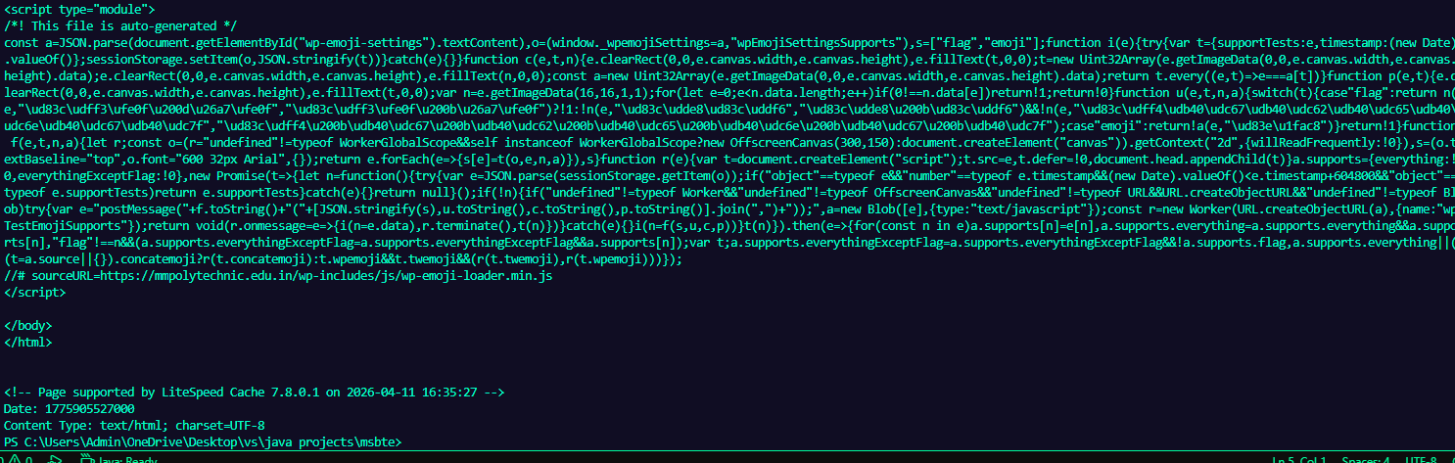
15. Write a program to implement the following:

i) Accept string from user. ii) Display position of 'is' in the string.
iii) Display substring from position 4 to 9. iv) Display character at position 5.
v) Display the string in upper case. vi) Reverse the string and display it.
/* Write a program to implement the following:
i) Accept string from user. ii) Display position of 'is' in the string.
iii) Display substring from position 4 to 9. iv) Display character at position 5.
v) Display the string in upper case. vi) Reverse the string and display it. */
import java.util.Scanner;
public class Q_15 {
public static void main(String[] args) {
Scanner sc = new Scanner(System.in);
System.out.print("Enter a String:");
String str = sc.nextLine();
System.out.println("Position of 'is': " + str.indexOf("is"));
System.out.println("Substring from position 4 to 9: " + str.substring(4, 10));
System.out.println("Character at position 5: " + str.charAt(5));
System.out.println("String in upper case: " + str.toUpperCase());
StringBuffer sb = new StringBuffer(str);
System.out.println("Reversed string: " + sb.reverse());
sc.close();
}
}

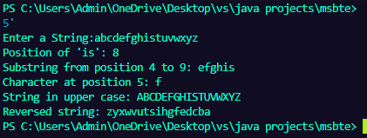
16. Write a program to throw 'NoMatchException' if the string entered by the user is not 'India'.
// Write a program to throw 'NoMatchException' if the string entered by the user is not 'India'.
import java.util.Scanner;
class NoMatchException extends Exception {
NoMatchException(String msg) {
super(msg);
}
}
public class Q_16 {
public static void main(String[] args) {
try {
Scanner sc = new Scanner(System.in);
System.out.print("Enter String: ");
String str = sc.nextLine();
sc.close();
if (!str.equals("India")) {
throw new NoMatchException("No Matched");
}
System.out.println("Matched");
} catch (NoMatchException e) {
System.out.println(e.getMessage());
}
}
}

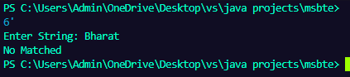
17. Write a program to accept two numbers in TextField and display their product in a third TextField when user clicks 'Multiply' button
// Write a program to accept two numbers in TextField and display their product in a third TextField when user clicks 'Multiply' button
import java.awt.*;
import java.awt.event.*;
import javax.swing.*;
public class Q_17 extends JFrame implements ActionListener {
JLabel l1, l2, l3;
JTextField t1, t2, t3;
JButton b;
Q_17() {
setLayout(new FlowLayout());
setVisible(true);
setSize(400,150);
l1 = new JLabel("Number 1:");
l2 = new JLabel("Number 2:");
l3 = new JLabel("Result:");
t1 = new JTextField(20);
t2 = new JTextField(20);
t3 = new JTextField(20);
b = new JButton("Multiply");
b.addActionListener(this);
add(l1);
add(t1);
add(l2);
add(t2);
add(new JLabel());
add(b);
add(l3);
add(t3);
}
public void actionPerformed(ActionEvent e) {
int n1 = Integer.parseInt(t1.getText());
int n2 = Integer.parseInt(t2.getText());
int result1 = n1 * n2;
t3.setText(String.valueOf(result1));
}
public static void main(String[] args) {
new Q_17();
}
}

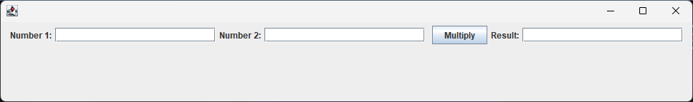
18. Write a program using UDP communication for Login Authentication.

19. Define a class employee with data members ‘empid’, ‘name’and ‘salary’. Accept data for three objects and display it.
// Define a class employee with data members ‘empid’, ‘name’and ‘salary’. Accept data for three objects and display it.
import java.util.Scanner;
class employee {
double salary;
int empid;
String name;
Scanner sc = new Scanner(System.in);
public void getData() {
System.out.print("Enter employee id:");
empid = sc.nextInt();
System.out.print("Enter employee name:");
name = sc.nextLine(); sc.nextLine();
System.out.print("Enter employee salary:");
salary = sc.nextDouble();
}
public void displayData() {
System.out.println("Employee id: " + empid);
System.out.println("Employee name: " + name);
System.out.println("Employee salary: " + salary);
}
}
public class Q_19 {
public static void main(String[] args) throws Exception {
employee[] emp = new employee[3];
for (int i = 0; i < 3; i++) {
emp[i] = new employee();
emp[i].getData();
}
for (int i = 0; i < 3; i++) {
System.out.println("Employee " + (i + 1) + ":");
emp[i].displayData();
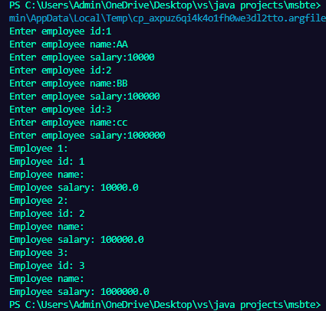
}
}
}

20. Define an exception called ‘No Match Exception’ that is thrown when the passward accepted is not equal to ‘MSBTE’. Write the program.
import java.util.Scanner;
// Define an exception called ‘No Match Exception’ that is thrown when the passward accepted is not equal to ‘MSBTE’. Write the program.
class NoMatchException extends Exception {
public NoMatchException(String message) {
super(message);
}
}
public class Q_20 {
public static void main(String[] args) {
try {
Scanner sc = new Scanner(System.in);
System.out.println("Enter password:");
String password = sc.nextLine();
sc.close();
if (!password.equals("MSBTE")) {
throw new NoMatchException("Password does not match!");
}
System.out.println("Password is correct.");
} catch (NoMatchException e) {
System.out.println("Exception occurred: " + e.getMessage());
}
}
}

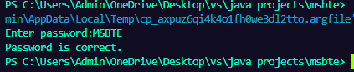
21. Write a program to print even and odd number using two threads with delay of 1000ms after each number.
// Write a program to print even and odd number using two threads with delay of 1000ms after each number.
class EvenThread extends Thread {
public void run() {
for (int i = 0; i <= 10; i += 2) {
System.out.println("Even: " + i);
try {
Thread.sleep(1000);
} catch (Exception e) {
System.out.println(e);
}
}
}
}
class OddThread extends Thread {
public void run() {
for (int i = 1; i <= 10; i += 2) {
System.out.println("Odd: " + i);
try {
Thread.sleep(1000);
} catch (Exception e) {
System.out.println(e);
}
}
}
}
public class Q_21 {
public static void main(String[] args) {
EvenThread evenThread = new EvenThread();
OddThread oddThread = new OddThread();
evenThread.start();
oddThread.start();
}
}

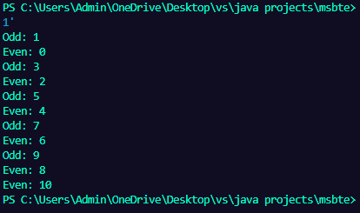
22. Develop a program to find area of circle using interfaces.
// Develop a program to find area of circle using interfaces.
interface Shape {
double area();
}
public class Q_22 implements Shape {
double radius;
public Q_22(double radius) {
this.radius = radius;
}
public double area() {
return Math.PI * radius * radius;
}
public static void main(String[] args) {
Q_22 circle = new Q_22(5);
System.out.println("Area of the circle: " + circle.area());
}

}

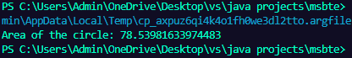
23. Define a package named myInstitute include class named as department with one method to display the staff of that department. Develop a program to import this package in a java application and call the method defined in the package.
// Define a package named myInstitute include class named as department with one method to display the staff of that department. Develop a program to import this package in a java application and call the method defined in the package.
import myInstitute.department;
public class Q_23 {
public static void main(String[] args) {
department dept = new department();
dept.displayStaff();
}
}

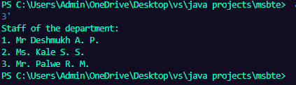
24. Write a program to create three Buttons with Caption OK RESET and CANCEL
// Write a program to create three Buttons with Caption OK RESET and CANCEL
import java.awt.*;
public class Q_24 extends Frame {
Q_24() {
setLayout(new FlowLayout());
setVisible(true);
setSize(300, 200);
Button b1 = new Button("OK");
Button b2 = new Button("RESET");
Button b3 = new Button("CANCEL");
add(b1);
add(b2);
add(b3);
}
public static void main(String[] args) {
new Q_24();
}
}

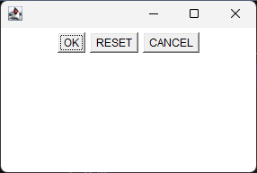

25. Develop an application using List components to add names of 10 different cities.
// Develop an application using List components to add names of 10 different cities.
import javax.swing.*;
import java.awt.*;
public class Q_25 extends JFrame {
Q_25() {
setLayout(new FlowLayout());
setVisible(true);
setSize(300, 200);
List cityList = new List(10);
cityList.add("Pune");
cityList.add("Mumbai");
cityList.add("Delhi");
cityList.add("Bangalore");
cityList.add("Chennai");
cityList.add("Hyderabad");
cityList.add("Kolkata");
cityList.add("Ahmedabad");
cityList.add("Jaipur");
cityList.add("Lucknow");
add(cityList);
}
public static void main(String[] args) {
new Q_25();
}
}

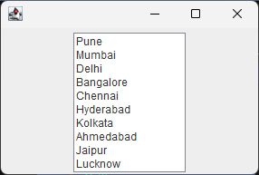
26. Write a program which creates Menu of different colors
// Write a program which creates Menu of different colors
import java.awt.*;
public class Q_26 extends Frame {
Q_26() {
setLayout(new FlowLayout());
setVisible(true);
setSize(300, 200);
MenuBar menuBar = new MenuBar();
Menu colorMenu = new Menu("Colors");
MenuItem redItem = new MenuItem("Red");
MenuItem greenItem = new MenuItem("Green");
MenuItem blueItem = new MenuItem("Blue");
colorMenu.add(redItem);
colorMenu.add(greenItem);
colorMenu.add(blueItem);
menuBar.add(colorMenu);
setMenuBar(menuBar);
}
public static void main(String[] args) {
new Q_26();
}
}

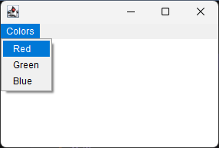
27.
import java.awt.*;
import javax.swing.*;
public class Q_27 extends JFrame {
Q_27() {
setLayout(new BorderLayout());
setVisible(true);
setSize(300, 200);
Button northButton = new Button("North");
Button southButton = new Button("South");
Button eastButton = new Button("East");
Button westButton = new Button("West");
Button centerButton = new Button("Center");
add(northButton, BorderLayout.NORTH);
add(southButton, BorderLayout.SOUTH);
add(eastButton, BorderLayout.EAST);
add(westButton, BorderLayout.WEST);
add(centerButton, BorderLayout.CENTER);
}
public static void main(String[] args) {
new Q_27();
}
}

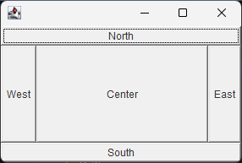
28.
import java.awt.*;
public class Q_28 extends Frame {
Q_28() {
setLayout(new GridLayout(3,2,10,10));
setVisible(true);
setSize(300, 200);
Button button1 = new Button("Button 1");
Button button2 = new Button("Button 2");
Button button3 = new Button("Button 3");
Button button4 = new Button("Button 4");
Button button5 = new Button("Button 5");
add(button1);
add(button2);
add(button3);
add(button4);
add(button5);
}
public static void main(String[] args) {
new Q_28();
}
}

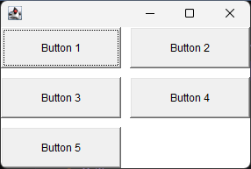
29. Write a program using JTextField to perform the addition of two numbers.
// Write a program using JTextField to perform the addition of two numbers.
import javax.swing.* ;
import java.awt.*;
import java.awt.event.*;
public class Q_29 extends JFrame implements ActionListener {
JLabel l1, l2, l3;
JTextField t1, t2, t3;
JButton b1;
Q_29() {
setLayout(new GridLayout(4,2,10,10));
setVisible(true);
setSize(300, 200);
setDefaultCloseOperation(JFrame.EXIT_ON_CLOSE);
l1 = new JLabel("Number 1:");
t1 = new JTextField(20);
l2 = new JLabel("Number 2:");
t2 = new JTextField(20);
b1 = new JButton("Add");
b1.addActionListener(this);
l3 = new JLabel("Result:");
t3 = new JTextField(20);
add(l1);
add(t1);
add(l2);
add(t2);
add(new JLabel());
add(b1);
add(l3);
add(t3);
}
public void actionPerformed(ActionEvent e) {
int num1 = Integer.parseInt(t1.getText());
int num2 = Integer.parseInt(t2.getText());
int sum = num1 + num2;
t3.setText(Integer.toString(sum));
}
public static void main(String[] args) {
new Q_29();
}
}


30. Write a program using URL class to retrieve the host, protocol, port and file of URL http://www.msbte.org.in.
// Write a program using URL class to retrieve the host, protocol, port and file of URL http://www.msbte.org.in.
import java.net.*;
public class Q_30 {
public static void main(String[] args) {
try {
URL url = new URL("http://www.msbte.org.in");
System.out.println("Host: " + url.getHost());
System.out.println("Protocol: " + url.getProtocol());
System.out.println("Port: " + url.getPort());
System.out.println("File: " + url.getFile());
} catch (Exception e) {
e.printStackTrace();
}
}
}

